**A**

**Report**

**on**

**Forest Management System**

**BACHELOR OF TECHNOLOGY**

**[4th Semester]**



Submitted by :- Submitted to :-

Mukul Raj Singh Mr. Narendra Rawal

Sudhanshu Gupta Department of Computer Siddhant Pal Science & Technology

Rajat Yaduvanshi

( B.tech 4th Semester )

**DEPARTMENT OF COMPUTER SCIENCE & ENGINEERING**

**SCHOOL OF ENGINEERING AND TECHNOLOGY**

**HNBGU (A CENTRAL UNIVERSITY) , SRINAGAR (GARHWAL) – 246174**

**CONTENT**

Chapter 1. Introduction

1.1-Role of forest management

1.2- scope

Chapter 2. literature Survey

2.1 – What for web server?

2.2- selection of web technology

2.3- database management selection

Chapter 3. System requirements

3.1- Software specifications

Chapter 4-Design

4.1-User interface

4.2-Modules

Chapter 5. Conclusion and further enhancements

Chapter 6. References

**Chapter - 1**

**Introduction:-** Forest management is the process of planning and Implementing practices for the stewardship and use of forests and other wooded land to meet specific environmental , economic ,social and cultural objectives.

Forest Management may be defined as the practical application of business methods and technical forestry principles to the operation of a forest resource. The Forest Management Plan is based upon a detailed social, economical and environmental appraisal, setting out the order and extent of all activities to be carried out in a concession. The Operational Plan addresses activities during specific periods of three to five years in greater detail. Annual plans are designed to set out activities for one year. Sound Forest Management involves the integration of the biological, social and economical aspects of the forest resource. This results in a sound planning process allowing a balance that makes the integration of the biological, environmental, social and economical factors viable.

The Forest Management Plan is designed therefore to achieved the following objectives:

1. To establish the administrative capacity to manage the plan area

2. To describe and evaluate the commercial potential of the forest resources in the plan area

3. To protect fragile land on steep slopes, protecting water supplies and protecting the forest’s wildlife and biological diversity in general

**4.** To sustain the supply of other forest products and services

5. To lend support to research investigations which will in turn support the objectives of management.

**Role of forest management:-**

The role of the project is it is very helpful project for forestry department .And in this project we will secure the trees . This is expressed more clearly in the Spanish expression for it, ordenación demontes, which suggests the need to introduce ‘order’. In Latin America the term manejo is more common. This word covers the idea of manipulation and management, and is closer to the English term.

In view of the need to take emergency action in a situation in which the environment is fragile and challenged, in order to re-establish a proper sustainable balance between resource and use, it is essential to take action in full knowledge of the facts (causes and effects). Consequently, forest management must be objective and scientific. However, in other contexts, which have emerged and more recently because of a lack of resources, skill or will, this has not been done, as the following descriptions of the practices adopted in Africa and India reveal.

**Scope:-**

forest management was based on rules used in the temperate countries by the European forestry schools, but with limited and partial experience and familiarity with an environment which was certainly more complex and more fragile than those in the countries of the colonial powers  to produce the fuel which was vital for the steam trains running along the Dakar-Bamako line, 18.000 ha were harvested using the simple coppice system. Blocks of 100 ha (4 km along the railway line, 250 m in depth) were simply clear-cut, with a yield of 35 stacked m3 of timber per ha. The management was certainly very rudimentary, but not totally non-existent. However it very quickly became clear that the forestry regeneration capacity had been overestimated and that the side-effects caused by the movement of the population towards the railway line had been underestimated.

**Chapter- 2**

**What for web server?**



Wampserver is used in the the making of this project. WampServer refers to a [software stack](https://en.wikipedia.org/wiki/Solution_stack) for the [Microsoft Windows](https://en.wikipedia.org/wiki/Microsoft_Windows) operating system, created by Romain Bourdon and consisting of the [Apache web server](https://en.wikipedia.org/wiki/Apache_HTTP_Server), [OpenSSL](https://en.wikipedia.org/wiki/OpenSSL) for SSL support, [MySQL](https://en.wikipedia.org/wiki/MySQL) database and [PHP](https://en.wikipedia.org/wiki/PHP) programming language

(2.2)- **selection of web technology:-**

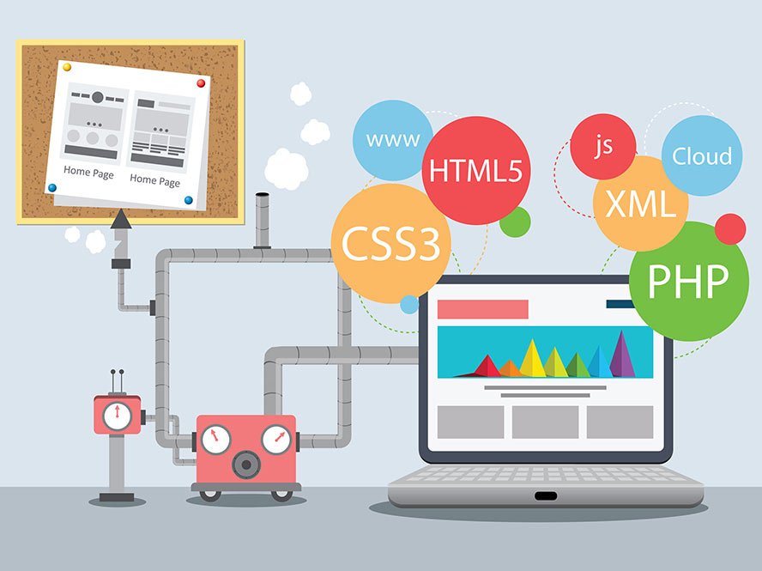

In this project we are used in three languages html ,php and css languages. The body are design by the html language . and the php is used for a give connection on the database.for to stored the data of our website. Next is the css. Css are used for a web design to decorate our website. There are the three languages are used in a project which is name as forest management system.

(2.3)- **Database Management Selection:**-

 In the project we are used a local server that is wamp server. and the data are stored in a database . In database we are make a two table. First is admin and second is forestdata. In admin table we are stored the admin login and password related details. And second table are created for to stored a information’s and delete the information.

As management information systems become more and more "data centered", the software chosen to handle the data becomes more crucial to the system's overall successful operation. But how does a user procure a DBMS that is right for his or her needs? What are the questions that the user should be asking the vendor, and how should the vendor answers be evaluated? These are the central issues to be considered by this panel session. In this session, therefore, panel members will consider the DBMS user's problems in selecting DBMS software. Based upon personal experience and insight in this area, each panel member will seek to identify the central issues which must be considered in the DBMS selection process, including such problems as benchmarking and other pre-selection testing, general selection criteria, cost evaluation, transportability, security, conversion, and reliability. After presenting some of the basic issues, the panel will come to some conclusions as to how managers in industry and government can approach their own DBMS procurements.

**Chapter -3.**

(System requirements)

(3.1)- Software specifications:-

A software requirements specification (SRS) is a document that captures complete description about how the system is expected to perform. It is usually signed off at the end of requirements engineering phase.

This document is also known by the names SRS report, software document. A software document is primarily prepared for a project, software or any kind of application.

There are a set of guidelines to be followed while preparing the software requirement specification document. This includes the purpose, scope, functional and nonfunctional requirements, software and hardware requirements of the project..

This project is designed in php, html, java, css. The whole coding of our program is done in php, html, java and the designs like background images, and other decorations are done by using css.

**Chapter -4**

**(Design)**

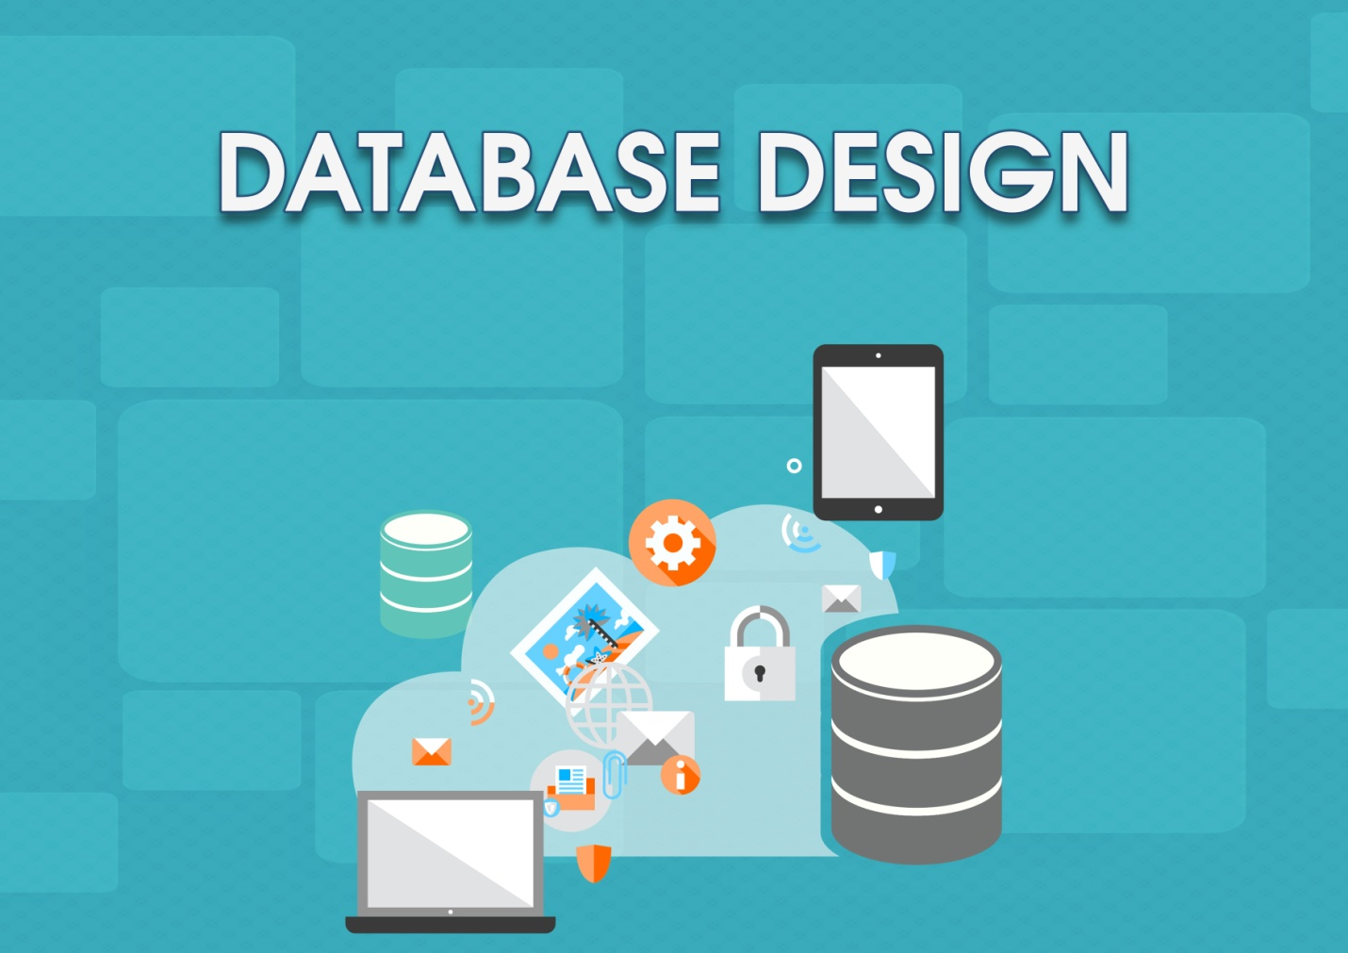

**(4.1) User Interface:- User interface provides a interface between user and the site to search about the whole information about the particular leaf and through this page admin can login to add, delete, update the informations about the leaf.**



**(1) Home Page:-**

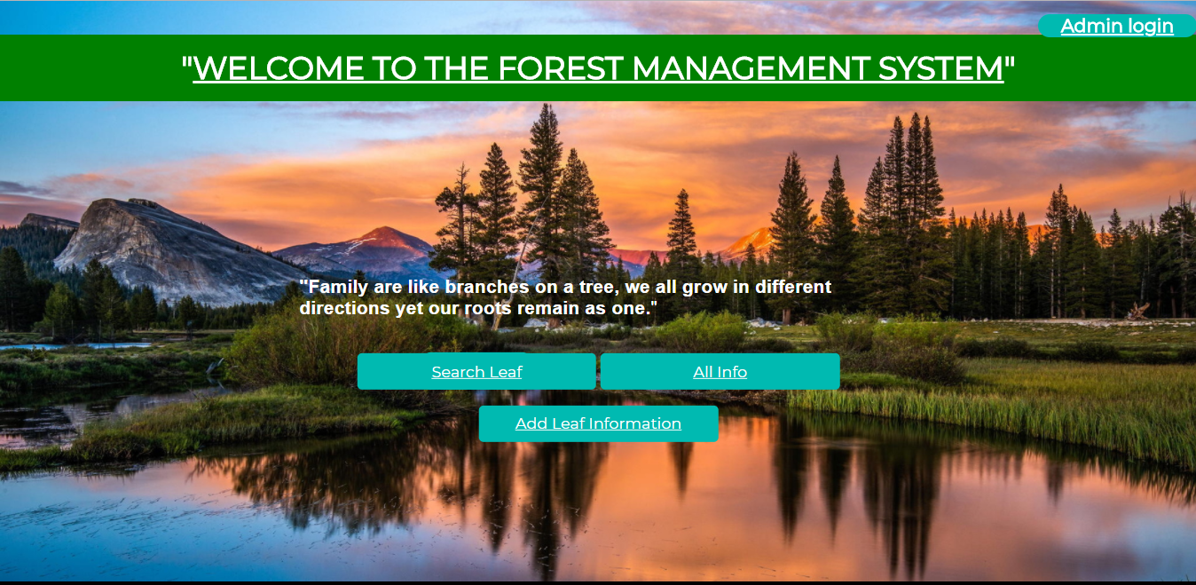

**This is the home page of the project. Through this page any new or other user can search the whole information about the particular leaf.**

**And he can also add the information about the other leaf in the data base. For adding information about the other leaf to the data base he can simply click on the add leaf information button and after that he can add the leaf information about the particular leaf. Through this page admin can also login into its account and then he can easily add, delete or update the information about the particular leaf and he can also change his password through admin login page.**

**(4.2).Modules:-**

**(1) Search Leaf Page:-**

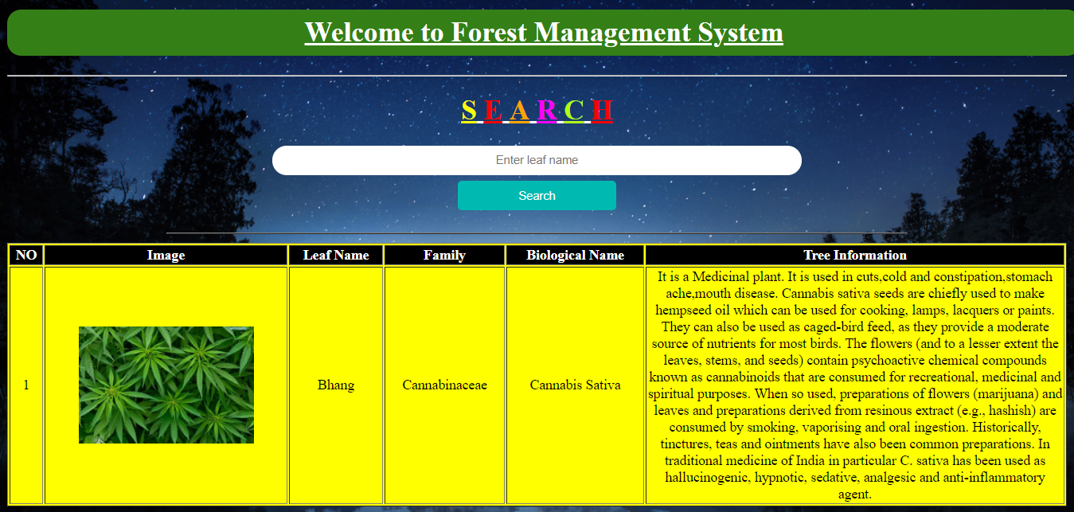

**This is the search leaf page of the program. Through this page any user can easily search the whole information about that particular leaf. So, as shown in figure user enters the leaf name ‘Bhang’ in the search box and then after clicking on search button the whole information about the ‘Bhang’ leaf is displayed on the page and user can easily access the information about the particular leaf.**

**So, in this way any user can easily access the whole in information about his required leaf.**

**(2) All Info Page:-**

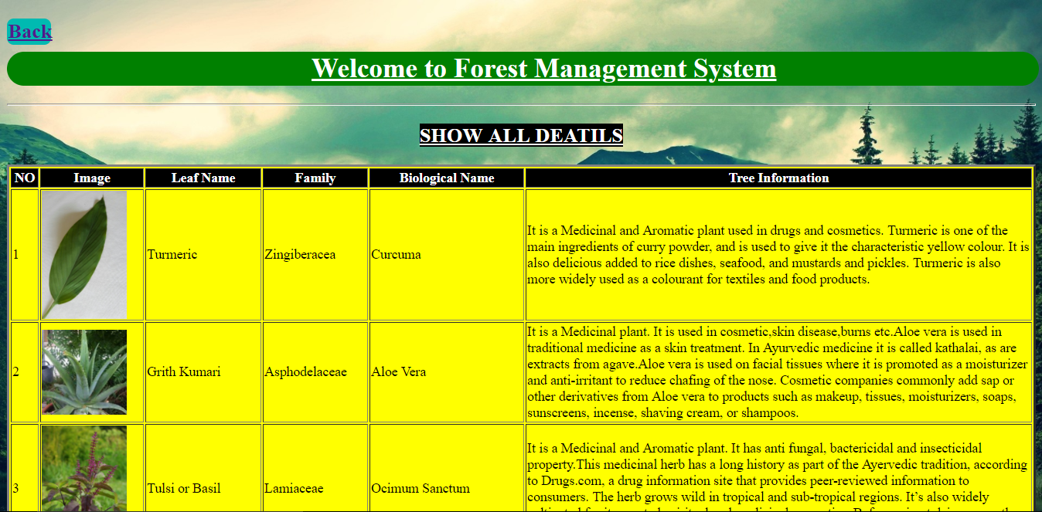

**This is the all info page of the project. Through this page the user searched about any leaf in the search box will be able to access or see the whole information about that particular searched leaf. In this page all the information about the all leafs are been shown and through this page user can easily get all the details or information about all the leafs.**

**(3) Add Leaf Information Page:-**

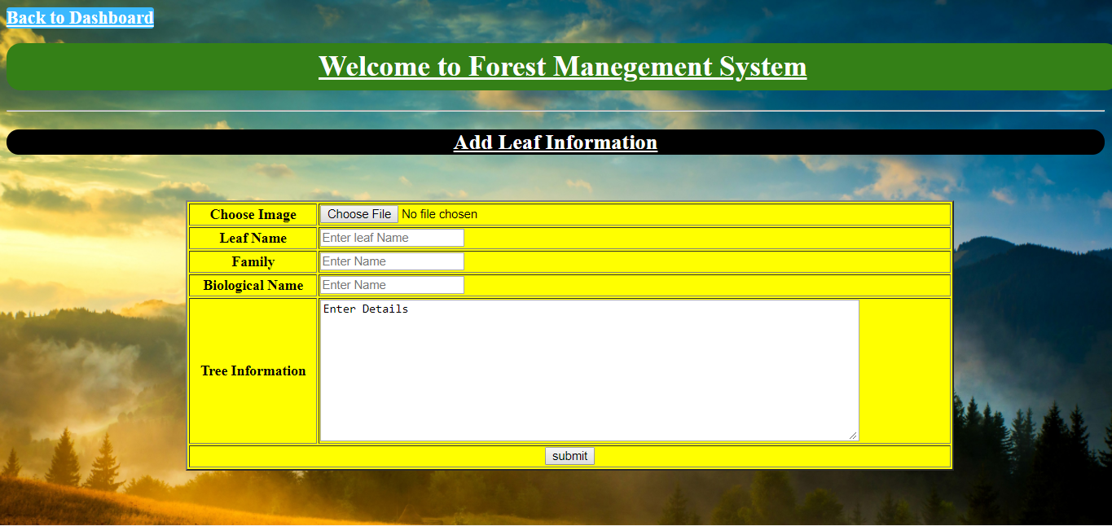

**This is the add leaf information page of the project. Through this page any new or other user can easily add the whole information about any particular leaf to the data base. This page provides the options to the user to add the information about any new leaf. Through this page user can enters the leaf image, leaf name, family, biological name and leaf information and when he click on the submit button the whole informatons about that particular leaf is stored in the data base and it is also visible to all the users in the all info page.**

**(4) Admin Login Page:-**

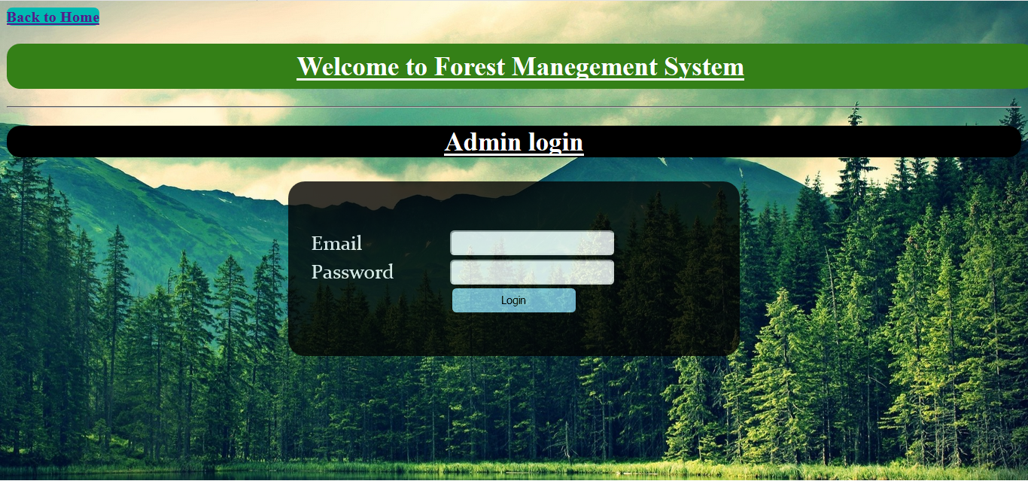

**This is the admin login page of the project. This page is designed only for the admin and only he can access the login page by entering the email and password and no other person can access the login page. And when admin login into the page he can easily add the leaf information in the data base, delete the information from the data base update the present information to the data base and he can also change the admin login password through that page.**

**(5) Admin Dashboard:-** 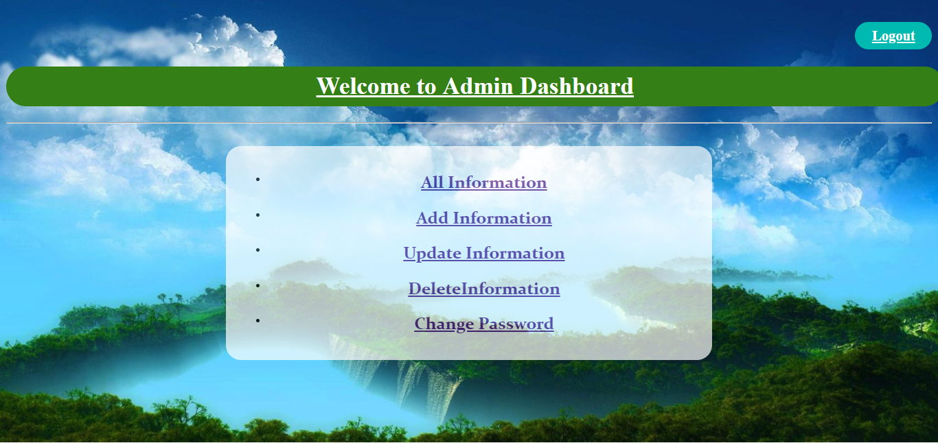

**This is the admin login page of the project. This page is specially designed only for the admin and only admin can access this page by entering its valid email and password. Through this page admin can manage all the informations about the leafs. In this page admin has various options to manage the whole information about the leafs. Through this page admin can add information about the leafs through add information option and he can update the present leafs informations through the update information option he can also delete any leafs informations through the delete information option and if the admin wants to change his admin password then he can also change the password through the change password option. And when all the managements done then the admin can easily leave the page through the logout option.**

**(6) All Info Page:-**

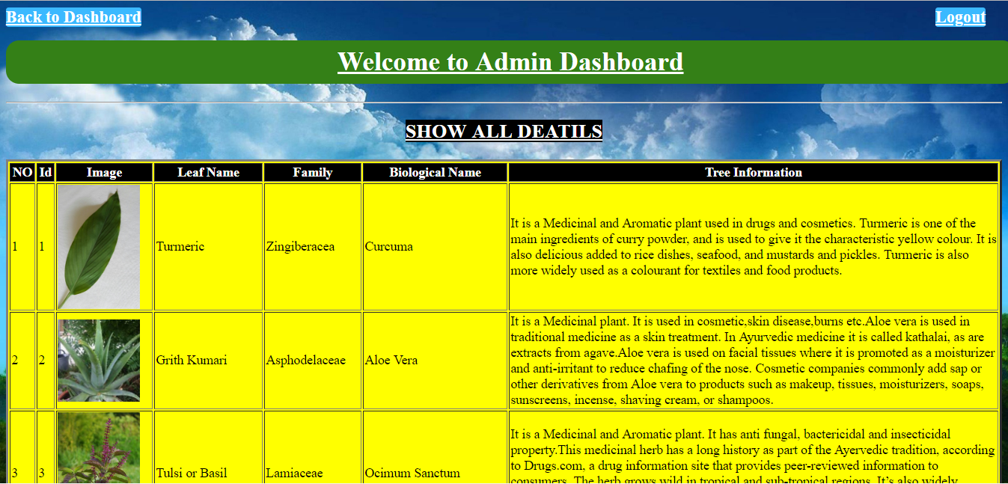

**This is the all info page of the project. Through this page all the information added by the admin in the data base is the over view. And all the information added by the admin is stored in the data base and all the leaf have its unique id through which admin can easily delete or update the leaf information. In this page all the information about the all leafs are been shown and through this page admin can easily get all the details or information about all the leafs.**

**(7) Add Information Page:-**

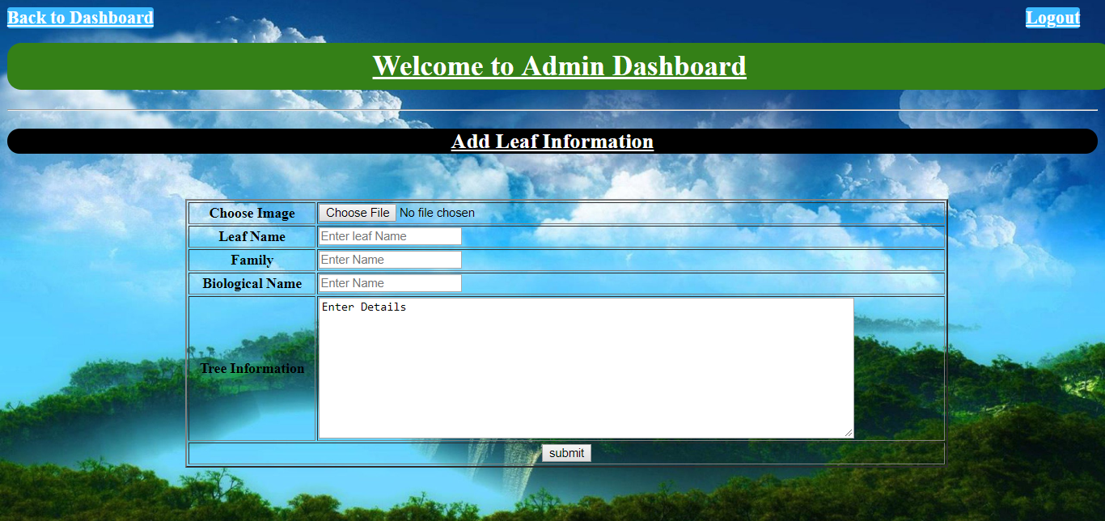

**This is the add leaf information page of the project. And it is add leaf information through the admin. Through this page any new or other user can easily add the whole information about any particular leaf to the data base. This page provides the options to the user to add the information about any new leaf. Through this page user can enters the leaf image, leaf name, family, biological name and leaf information and when he click on the submit button the whole informatons about that particular leaf is stored in the data base and it is also visible to all the users in the all info page.**

**(8) Update Information :-**

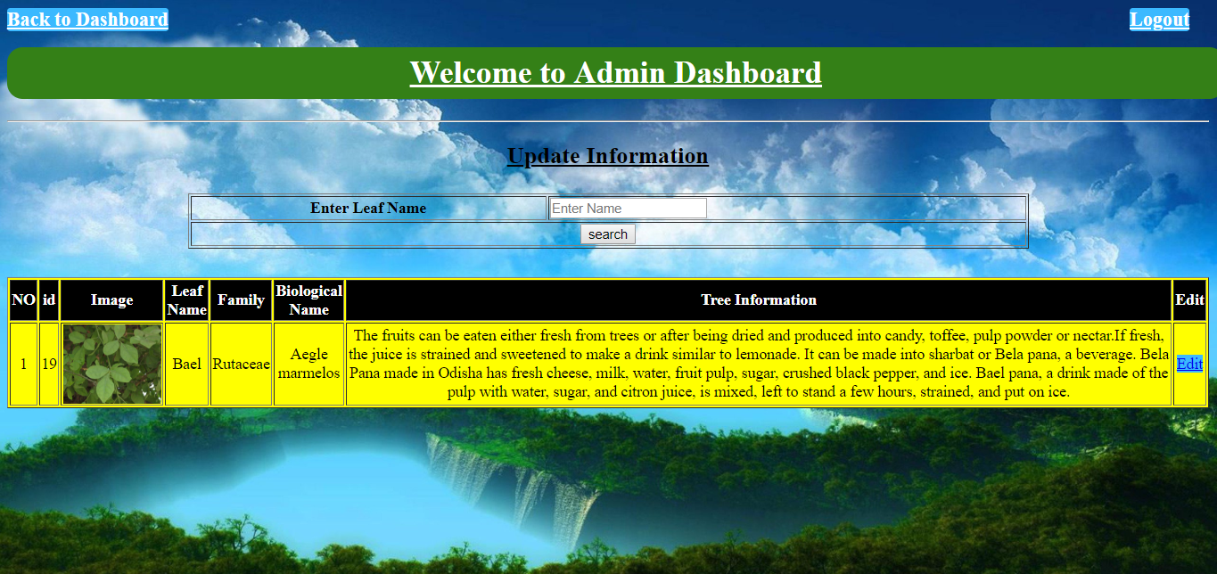

This is the update information page of the project. Through this page admin can update the previous data to the data base. The admin can update data by entering the unique name of the leaf. When admin enter the unique name of any particular leaf in the search box then the previous information stored in the data base will be automatically fetched from the data base and will be shown on the page.

When all the previous Information are shown on the page then admin can update the informations through the edit button.

(9) Delete Information:-

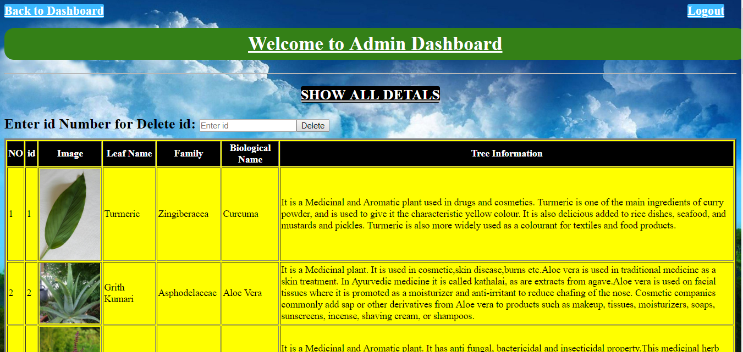

This is the delete information page of the project. Through this page admin can delete the previous data to the data base. The admin can delete data by entering the unique id of the leaf. In this page all the previous data stored in data base will be shown on this page and when admin enter the unique id of any particular leaf in the search box then the previous information stored in the data base will be automatically fetched from the data base and will be deleted from the data base.

So, in this way admin can easily delete the particular leaf information from the data base. And this authority can be given only to the admin.

(10). Change Password Page:-

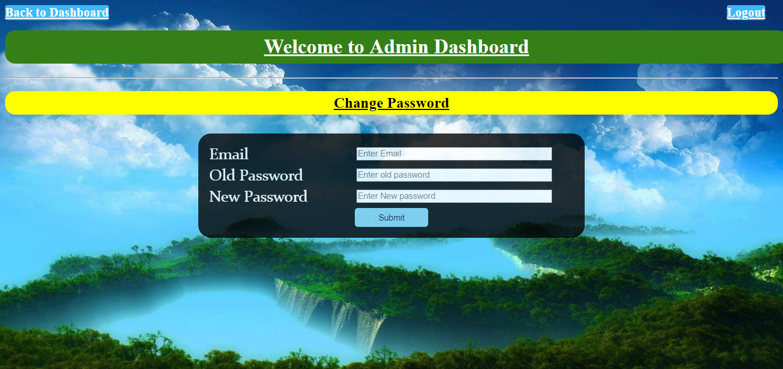

This is the change password page of the project. This page is specially designed only for the admin and not for the other users. If admin wants to change his old password the he can simply enters his email and old password and after verifying the old password the admin can enters his new password and then clicking on the submit button the old password is replaced by the new password.

After changing the password admin will go back to the admin login page and enters his email and the new password to manage info.

**Chapter- 5**

.

**CONCLUSION**

In this conclusion Forest Management System plays a main role in the collection of data and managing information realted to the welfare and development of forests.Without, Forest management system we can’t imagine or can’t have a image of finely managed database system .

The term foundation suggests that we cannot just jump to emerging area, and neglect traditional areas, because new discipline have enduring needs that are based on evolving knowledge about biology, ecology, forest management, measurement, policy, and other forestry research and education discipline. For instance, complex forest health monitoring issues still revolve around basic information about tree physiology, response to nutrients or pathogens in the atmosphere and soil, pest/host interactions, and climate. These foundation areas require continued focus, people, and funds for scientists to improve theirBottom of Form understanding of basic biophysical processes.

Chapter 6. References

* Youtube videos
* [www.Google.com](http://www.Google.com)